SHADOW EATERS
A Dark Side in the Reformed Faith

by
Roger Smalling, D.Min

This article corresponds to the book
Joyfully Justified
available in Kindle.
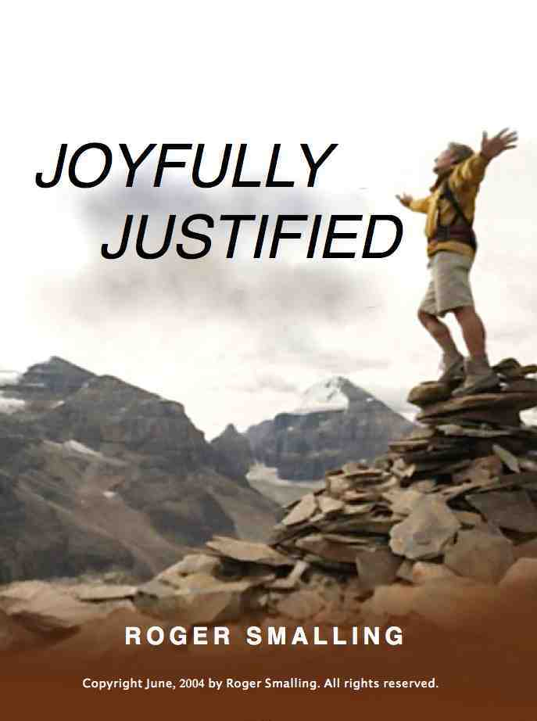

It is for freedom that Christ has set us free. Gal. 5:1

A British naturalist who collected animals for zoos, Gerald Durrell, tells how he captured a number of African birds and small mammals. He kept them in cages for several weeks. Due to political turmoil, he could not export the animals to Britain and was forced to free them.

He opened their cages to let them go. To his surprise, some refused to leave. They had become comfortable in their cages, nourished and sheltered from predators. He resorted to prodding them out with a stick but the moment he stopped, they went back in.

Durrell was obliged to destroy the cages to prevent the animals from staying. They had lost their taste for freedom.

So it is with some Christians. They prefer the secure confines of rules, only to miss out on a world of adventure.

“Every man harbors a Pharisee in his heart,” observed the radio preacher. I agree. Remnants of corruption remain as long as we live, and often generate legalism.

Legalism is the assumption we get righteousness by following rules. Like the Galatians, some suppose we are justified by faith but sanctified by law. Paul protests,

Are you so foolish? After beginning with the Spirit, are you now trying to attain your goal by human effort? Gal. 3:30

The other day I wanted something. I thought to myself, “I’ve been good lately. God will probably give me what I ask.” A moment later, I realized this thought was atrocious.

I had fallen into the familiar trap of legalism, assuming God would reward me for my own righteousness. “You old Pharisee!,” I thought. “You teach grace and then assume God might bless you on the grounds of your own goodness.”

Why do we relapse into such snares? None of us escapes entirely the influence of our old nature. A subtle drive for autonomy and self-validation remains.

Our old nature is ego-centered. This feeds legalism. Since God’s law did not originate from the self, man feels the urge to supplement it. We develop new rules apart from those God gave. Urging others to comply is even better since it lends an illusion of authenticity. Our sinful nature considers religious practices acceptable as long as self is in control.

The legalist misses the point: Self is the problem. Attempting righteousness by rules only strengthens our autonomy. This in turn leads to more sin.

Are rules bad? No. However, rules can never produce righteousness. The Ten Commandments are still valid. We sin by breaking them, but they are powerless to make us righteous.

Legalism does nothing to improve carnality. The proof is in the way legalists treat free people.

Reformed legalism
Every Christian movement has its unique brand of legalism. Since grace is the central theme, we would expect the reformed movement to be free of legalism. Some have avoided it. Others, considering themselves ‘truly reformed’, have fallen headlong into it.

This is a warning. Like a tree, all movements develop branches while maintaining core values. Some branches are fruitful, others sterile. Even within grace theology, legalism exists and some would rob us of our liberty.

Why grace works and legalism does not
Grace succeeds because it is based on a relationship with Christ. He is not only sufficient but also indispensable. He is not a supplement to our righteousness. He IS our righteousness.

Some fear the freedom of grace may lead to a disregard of the divine law. The opposite is true. We find ourselves following Christ more closely, who is always in accord with the divine law. Here’s the biblical pattern:

For the grace of God that brings salvation has appeared to all men. Titus 2:11

First, grace brings salvation. We do not bring it to ourselves. What then? Does grace say, “I started you on the right path. The rest is up to you.”?

It teaches us to say “No” to ungodliness and worldly passions, and to live self-controlled, upright and godly lives in this present age, V.12

Once grace brings salvation, it stays around and teaches us godly living. Any who imply that grace is freedom to sin, are calling licentiousness by the wrong name.

When we grow in grace, we become more free yet less libertine. Grace allows us to relish our present acceptance with God, as opposed to the legalistic mere possibility of a future acceptance.

Legalists suppose they have divine authority
The legalist is convinced he is standing firmly on the authority of the divine law. Instead, he has one foot on the law and the other on the remnants of his own corrupt nature. This is slippery ground. Neither foot is planted on the imputed righteousness of Christ. The sins of pride, self-righteousness and judgmentalism have foothold.

Laws always produce more laws, not more righteousness. They multiply like germs in a Petri dish. This is why Jewish Rabbis, not content with Old Testament law, wrote the Talmud, a set of volumes expanding the law to the size of an encyclopedia.

Legalists imagine they are mature
Freedom is an ambiguous concept, tricky to define. Where does freedom end and license begin? Laws are concrete while principles are ethereal. Children require rules due to their undeveloped faculties. As they mature, they understand the principles.

Paul alluded to this,

Therefore the law was our tutor to bring us to Christ, that we might be justified by faith. 25 But after faith has come, we are no longer under a tutor. Galatians 3:24-25 (NKJV)

We can remain children led by a tutor if we choose. Or we may be free, mature adults acting on principle.

Accept him whose faith is weak, without passing judgment on disputable matters. Rom. 14:1

The legalist is a spiritual weakling. Like a straw man propped up by sticks, so the legalist props himself up by petty rules. Though he thinks he strong, he is going nowhere.

Rules are like scaffolding for building a wall. Once the wall is built and can stand on its own, the scaffolding is no longer needed.

Legalists assume strictness is holy
Since you died with Christ to the basic principles of this world, why, as though you still belonged to it, do you submit to its rules: 21 “Do not handle! Do not taste! Do not touch!”? 22 These are all destined to perish with use, because they are based on human commands and teachings. 23 Such regulations indeed have an appearance of wisdom, with their self-imposed worship, their false humility and their harsh treatment of the body, but they lack any value in restraining sensual indulgence. Colossians 2:20

Religious strictness usually makes things worse. Paul had been a strict Pharisee, so he knew the legalist mindset. Pharisees were detailed about laws. It was the one about murder they overlooked.

More strict equals more sin. Why? Because the power of sin is the law. It is the crutch on which the carnal nature leans to work at full capacity.

God’s risk
You, my brothers, were called to be free. But do not use your freedom to indulge the sinful nature; rather, serve one another in love. Galatians 5:13

Live as free men, but do not use your freedom as a cover-up for evil; live as servants of God. 1Peter 2:16

Free from what? From rule-based righteousness. Humanly speaking, God takes the risk that we might abuse our freedom to indulge the flesh. If this were not so, these warnings would not be in scripture. The warnings are proof of how just free we are.

Should we fear we might abuse grace? That’s like a doctor saying, “I’m giving you a prescription but be careful because it might make you forget you are sick.” This is precisely what the prescription is intended to do.

How does legalism enter the reformed camp?
Some reformed teachers ignore an important principle of biblical interpretation: the New Testament interprets the Old, not vice versa.

It happens due to a misuse of the idea of covenant. God made a covenant, a kind of agreement, with Abraham. This is the Christian covenant, sometimes called the covenant of grace. Galatians Chapter Three teaches this clearly.

This covenant binds the Old and New Testaments together. Some reformed teachers take this concept further than the apostles intended. Launching from the idea of the unity of the testaments, they drag Old Testament law into Christian living. Such practice is like reading the Bible to the end, then like a rubber ball hitting a wall, bouncing back and getting stuck in Deuteronomy.

Shadow-eaters
The law is only a shadow of the good things that are coming — not the realities themselves. Hebrews 10:1

Imagine a person trying to eat a shadow. Such a ludicrous sight must be how God views us when we fall into legalism. To some, the shadow seems so real, while the reality is ethereal. A lamb sacrifice seems concrete, the atonement of Christ ethereal. Shadows make poor nourishment.

The Book of Hebrews is the New Testament’s declaration about the Old Testament and how much of it applies to Christians.

Which of these two propositions is correct?
- From the Old Testament, we accept into Christian living anything the New Testament does not prohibit.
- We accept from the Old Testament only those things the New Testament says we must.

The second proposition is correct. If the law is only a shadow, then it makes no sense to drag from it everything we can into Christian living.

The Old Testament is what the New Testament says it is and no more. We have no authority to drag anything into Christian living from the Old Testament unless the New Testament requires it. If we do, we are attempting to feast on shadows rather than realities.

This pattern of shadows versus realities is the underlying structure of the Book of Hebrews. Everything in the law is a shadow unless the New Testament says it is not. What aspects of the law does the New Testament authorize for Christians?
- The moral law as expressed in the 10 Commandments.
- Examples of divine judgments so we may avoid evil. 1Cor. 10:6
- A resource for worship. Eph. 5:19
- The covenant of grace. Gal.3:1-14

That’s about it.

Some reformed teachers start with the wrong proposition and insert into the New Testament errors of emphasis we will study below. Several exist but we will touch on two prominent ones.

Strict sabbattarianism
Two views of the Sabbath prevail among reformed churches: Those who believe the Sabbath is a day, and those who believe it is not a day. The former, we may call sabbattarians, the latter non-sabbattarians.

Sabbattarians believe Christ changed the Old Testament Sabbath from Saturday to Sunday by rising from the dead on the first day of the week. Since the only thing changed is the day, the original Old Testament injunctions against working or recreation on the Sabbath must be in force. The only works allowed are necessary social services, such as medical personnel or police.

Non-sabbattarians declare the Old Testament Sabbath was only a symbol pointing to faith-rest in Christ. The Sabbath, by this perspective, is not a day and was never meant to be. Sabbath observance therefore has no more inherent value than a lamb sacrifice. If we ask a non-sabbattarian if he keeps the Sabbath, he is likely to reply something like, “Yes, I keep it every day, because I trust in Christ every day.”

Both camps agree, however, that Christians should worship on Sunday because this is the day on which Christ rose from the dead.

Regardless of one’s position, our desire is to warn against any who would lead one into legalism by dictating what they can or cannot do on Sunday.

Even among sabbattarians, opinions vary about what is permissible on Sunday. Some refrain from going to a restaurant because it obligates others to work. They eat at home. Instead of the waitress working, Momma does. Even if the food is prepared the day before, somebody puts it on the table and washes the dishes.

I have two friends who practice this whom I do NOT consider legalists. Why not? Both declare they practice this is a matter of personal preference to honor the Lord, while respecting the consciences of those who do otherwise. This is not legalism. It is their form of worship.

During my ordination exam, someone asked if I thought it was permissible to play ball on Sunday after church. I replied, “For you guys who have kids, this is what I recommend. After church, put your Bible away, take the kids to the park, play ball and count it is a work of mercy for your wife.” To my delight, the assembly erupted in laughter and passed the question.

What was the attitude of the apostles about this?

Therefore do not let anyone judge you by what you eat or drink, or with regard to a religious festival, a New Moon celebration or a Sabbath day. 17 These are a shadow of the things that were to come; the reality, however, is found in Christ. Colossians 2:16

Therefore let us stop passing judgment on one another. Rom. 14:13

Paul declares we have a certain freedom of conscience with regard to how we celebrate the Lord’s Day. We are free to celebrate according to our conscience. We are not free to judge one another.

The regulative principle
In Canada a few years ago, a controversy arose over a bizarre practice of hysterical laughter in some churches. It was called ‘holy laughter.’

The proponents of this movement defended it by the question, “Where in the Bible do you see it forbidden?” Others asked, “Where in the Bible do you see it commanded?”

Which regulates Christian worship? Anything not forbidden or only what is commanded? Logically, it must be one or the other.

The second option is biblical. God himself regulates worship by his word. We are not free to do whatever we please. We call this the regulative principle.

In the Old Testament, we see worship regulated to the last detail. As we would expect, this principle is broadened in the New Testament. We see commands by the apostles to ‘sing songs, hymns and spiritual songs,’ preach the word, administer ordinances and serve one another.

That’s about it. Rather broad, isn’t it? We would expect this of apostles who celebrated a new freedom in Christ.

The way some Reformed teachers treat the relationship between the Testaments reminds me of people who dislike the shape of a French horn. They take a hammer and laboriously straighten it out so the exit is as narrow as the mouth. Then they look up with a satisfied smile, pleased at the intensity of their labors and depth of wisdom about the correct shape of French Horns.

Perhaps the tone of their horn sounds better to them. To me, it sounds hollow.

Since the gospel is now for people of all cultures, we see the practicality of a broadening of the regulative principle. Cultures vary widely in music and expression of worship.

Some reformed people are uncomfortable with the spirit of freedom in worship we see in the New Testament. As with other aspects of Christian life, freedom frightens them. So they question every practice, attempting to bind the conscience of Christians with details about worship.

One small denomination forbids the use of musical instruments. Part of the complex argument they use, is that musical instruments are not commanded in the New Testament. (Legalists need complicated arguments to justify their position. Freedom is simple.)

True, we find no command in the New Testament to use musical instruments. What we find is the command to live as free men, within the broad limits the New Testament authorizes.

Other issues?
Christians have asked me, is tithing obligatory? Are alcoholic beverages in moderation a sin? Should we sing Psalms only? What about altar calls? Are academic degrees necessary to preach?

If the reader has understood this chapter, he will already know the answers to such questions.

Conclusion
A friend said, “If you are not enjoying your freedom, then you need to talk to the Lord because you have a problem.”

If the Pharisee in our hearts has his way, he will bind us and that is no fun. Worse, he will use us to bind others.

As long as we are in the flesh, we will be at war with him. Do not let him win.

From this chapter we learn:
- Legalism is the assumption we may obtain righteousness by following rules.

- Legalism afflicts all Christian movements to some degree.

- Legalism is based on the remnants of corruption remaining in Christians.

- Being more strict is not necessarily being more holy.

- The Old Testament is what the New Testament says it is, and no more.

- We have no authority to drag into the New Testament anything from the Old Testament unless the New Testament says we may.

- Legalism sometimes enters the reformed camp by interpreting the New Testament in the light of the Old Testament instead of the reverse.

- In the New Testament, we have greater liberty in questions of worship and the Lord’s day.

Study Questions for Chapter 9
- What is legalism?

- Why does legalism in some form, afflict all Christian movements?

- Why do we say that legalists are immature?

- What is an error of interpretation some reformed teachers may commit? Why do they fall into it?

- Which book of the Bible most thoroughly describes the relationship of the Christian to the Old Testament?

- Which of the two presuppositions below are correct, and why?

  - Either we bring into Christian living from the Old Testament law anything the New Testament does not forbid,
  - Or, we bring into Christian living only those things the New Testament says we may.

- What do we mean by our freedom in Christ?

- In what way are we bound by the moral law, (the 10 Commandments) and in what way are we free from it?

- In what way have you been a legalist in your private Christian life and in your treatment of other believers?

Smalling's articles and essays are available at www.smallings.com

This article has been reviewed by three ministers of the Presbyterian Church of America and found to be consistent with Westminster Standards.
Durrell, Gerald. Bafut Beagles. Viking Press, London, England. 1981
1Corinthians 15:56
The New Testament repeats these commands in various forms. The student is welcome to study this for himself.
Others are Psalmody: The notion that only Psalms should be sung in public worship, not hymns or choruses. Theonomy: The notion that Old Testament judicial law should be imposed on society and that Christians should work toward this.
This view is held by Presbyterians and is taught in chapter 21 of the Westminster Confession. It was the position espoused by the English puritans who dominated the Westminster assembly. We may call this the Puritan view, although doing so irritates Presbyterians.
Seventh Day Adventists are free worship on Saturday as long as they do not condemn those who worship on Sunday.
This began in Toronto Canada in 1994 and spread rapidly to other countries. A good exposé is found at: http://www.orthodoxinfo.com/inquirers/toronto.aspx
1Cor. 8:9; 10:29; Gal. 2:4;1Pe. 2:16
A paraphrase of a comment by Greg Hauenstein, President of Miami International Seminary, Oct, 2004. 2005.

