Quit Calling Yourself a Sinner

by
Roger L. Smalling, D.Min

This article corresponds to the book
Joyfully Justified
available in Kindle.
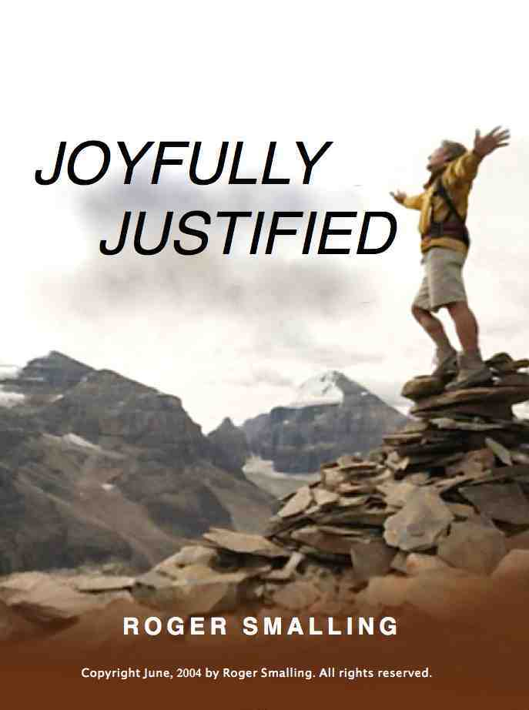

Quit calling yourself a sinner, at least not all the time. After all, God calls you a saint.

Yes, you are a sinner, all the time. Contradiction? No. I merely said, “Quit calling yourself that.”

Christians take their identity from Christ, not themselves. Adam no longer represents us. So God’s word is perfectly consistent in calling us saints even though we sin. Have you noticed how many epistles are written to sinners? None. How many to saints? All of them.

Nor does God seem interested in any balance between sinner and saint. So quit the balancing act and throw yourself headlong into grace. Wallow in it.

Christian movements often invent formulas for rising above temptation or the stresses of life. This allegedly frees the believer from the struggles others experience. This supposedly creates two classes of Christians: The elite who claim special victory, and the rest of us.

Some Pentecostals, for example, have their baptism in the Holy Spirit. After receiving this experience, one is elevated to a new dimension where struggles are minimal.

Nazarenes and Methodists believe in a sanctification experience in which the remnants of one’s carnal nature are supposedly eradicated. (They commit “mistakes,” but not sins.)

The reformed movement, despite its emphasis on the sovereignty of grace, has not escaped formulas. We will take a closer look in a moment.

For the sake of this chapter, we will label such formulas as mysticism. This is the belief that an elite status with God is attainable through a special religious experience, formula or insight.

Mystics view reality as a two-story house. On the bottom are carnal Christians, burdened with life. In the upper story are the victorious, who have tapped into the formula for living above other Christians. Mystics view Christians as belonging to two camps: the inferior kind and his kind.

Are they real?
Are we suggesting such experiences may not be real? To the contrary. I can accept that these believers have had a genuine encounter with God. We need to be filled with the Spirit, work on our sanctification and practice repentance. The theology they attach to these experiences is another question.

The main problem is these experiences are all partly true…but only partly. A half-truth is often more dangerous than a lie. Here’s the irony: The second story does not exist!

The New Testament never describes any spiritual experience or formula for attaining a status superior to other Christians. The Bible speaks instead about growth.

But grow in the grace and knowledge of our Lord and Savior Jesus Christ. Amen. 2Pet. 3:18

We grow steadily as we apply the simple means of grace God puts at our disposal: The Word, prayer and fellowship.

Not only is the second story a myth, the ladders leading to it are merely shadows. One can no more climb closer to God on them than we can climb a shadow. The only ladder provided is Christ alone and simple faith in him.

That is why all these experiences are only temporary. They may be valid encouragement for a while, but we confront the growth process eventually.

Reformed mysticism
The reformed movement, despite its emphasis on the sovereignty of grace, has not escaped mystical formulas. One of these is an emphasis on “living a life of repentance.”

The idea is that if we follow a certain repentance formula, groveling enough in the acknowledgement of our sinfulness, then God will grant us special grace to bump us to the upper story.

The formula is in three steps: First, we recognize our horrible sinfulness. Second, grovel in this until we feel really sorry. Third, pray a sinners’ prayer. Result: We will then experience profound joy and live victoriously above other Christians. We will be in the second story.

Where does this idea originate?
Sometimes Reformed teachers over emphasize our remaining corruption, while virtually excluding the positive identity of the believer. This may stem from the doctrine of total depravity, which is normally meant to describe the helpless state of the unregenerate.

From this follows a subtle assumption: If we grovel enough before God, he will take pity on us and grant more grace. However, this makes grace depend on a human ability to repent adequately.

Are some teachers afraid believers might not be humble enough? Of course we are not humble enough. We aren’t anything enough.

In one service I attended, the responsive reading included two pages of confession, such as:

People: We acknowledge that we are poor sinners, conceived and born in guilt and in corruption, prone to do evil, unable of ourselves to do any good, who, by reason of our depravity, transgress without end your holy commandments.

People: We confess that we have coveted the possessions and spouses of others; we acknowledge in summary that our whole life is nothing else than sin and transgression of your holy commandments and an inclination toward all evil.

There follows a long sinner’s prayer and the assurance of forgiveness.

Spiritual Identity theft
What is wrong with the procedure above? Nothing, per se. It is what it leaves out that concerns us.

Which are we? Sinners with grace, or saints with remnants of sin? The book of Ephesians gives the answer. In the first three chapters, we see a glorious description of what we are and have in Christ. The last three chapters exhort us to live worthy of this calling.

The positive is first. Paul declares we are saints and faithful brothers, and then tells us we should stop lying, fornicating, squabbling, etc. We are saints with remnants of corruption. We are not sinners with remnants of grace.

Does this mean we need not live a life of repentance? It depends on how we define that. As we read our Bibles daily, pray and engage in fellowship with other believers, we are attentive to the Holy Spirit who brings to the attention of our conscience what the Father wants us to correct. We confess it and go on from there.

If we make grace dependant our ability to repent properly and be grieved enough, the Pharisee in our heart has spoken again. This time his voice is quieter than a Pentecostal, with a more humble expression than a Nazarene. Either way, grace is no longer sovereign.

Finally, we must avoid giving the impression the essence of the Christian life is forgiveness of sins. Not so. Forgiveness is the first half of the gospel. The core is an imputed righteousness and a new identity as saints.

For those who have come out of Roman Catholicism, the idea of groveling before God probably sounds familiar. If you were a Catholic, did you practice this? Did it do you any good?

So stop “living a life of repentance” primarily. It’s like driving a car. We have a windshield and a rear-view mirror. Most of our attention is on what is ahead. Occasionally we check the rearview mirror to see where we have been.

Identity cure
Here’s a suggestion for aligning our self-concept with scripture. Take this list below, which comes from the first three chapters of Ephesians, paste them in your Bible and read them regularly. This is not a mystic formula. It is simply encouragement.

In Christ I am…
A saint and faithful believer
Blessed with every spiritual blessing
Chosen in Christ
Holy and without blame
Loved by God
Predestined as his child
Adopted by God
The praise of his glory
A trophy of his grace
Redeemed by his blood
Forgiven
Partaker of the riches of his grace
Heir of God
Sealed with the Spirit
Alive in Christ
Seated in Heavenly places
Saved by grace
Created for good works
Heir of the covenant
Access to the Father
Fellow citizen with the saints of God
Member of God’s household
God’s dwelling place
Bold access to the throne of God
Sealed for redemption
A child of the light
A member of Christ’s body

A pre-Christian Jewish Rabbi once said, “I get up, I walk, I fall down. Meanwhile, I keep dancing.” He had the right idea.

Though we still sin, we have a new identity. That’s reason for a lot of joy. So keep on dancing.

From this chapter we learn:

- Christians are saints with remnants of corruption, not sinners with elements of grace.

- Christian movements generally have some element of mysticism.

- Mysticism is the mistaken belief that a particular spiritual experience, formula or insight will grant a special status with God.

- The problem with all forms of mysticism is that no such special status exists.

- The reformed movement sometimes has its own mysticism that consists in an excessive emphasis on our remaining corruption and need for continual repentance.

- A potential problem with an emphasis on the reformed idea of ‘living a life of repentance’ is that it makes grace dependant on a human ability to repent properly.

Smalling's articles and essays are available at www.smallings.com

I find some Christians object to this statement, because they think of sin as specific acts rather than a state of being. I remind them of the command, “Be perfect, even as your father in heaven is perfect.” If we are not perfect, then we are sinning all the time. We are, of course, forgiven all the time as well. Christians who do not consider themselves sinners, either have a very low view of God, or a very high view of themselves.
A quote from Rabbi Hillel, who was the grandfather of Gamaliel, the mentor of Saul of Tarsus (the Apostle Paul). One can only speculate on the influence of Hillel’s thinking on Paul.

