How to Grow in Faith

by
Roger Smalling, D.Min

This article corresponds to the book
Personal Revival
available on Kindle.

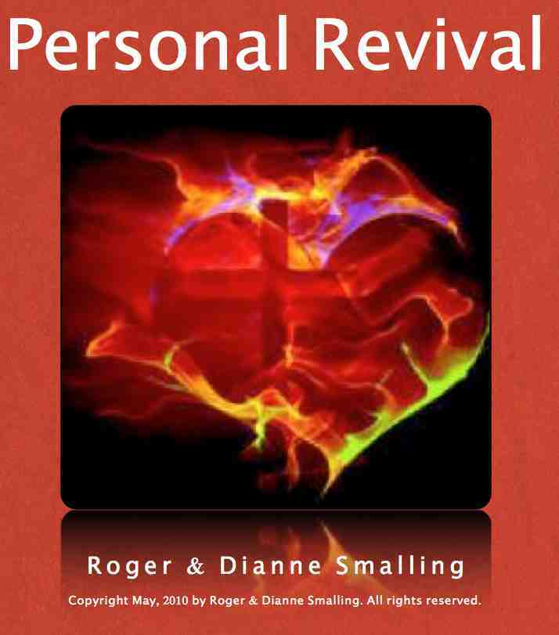

I thought a good twenty year stretch on the mission field would make me a nigh invincible man of faith and power. Though I've learned a lot, I still encounter areas of weakness.

Ministry has a way of drilling faith into a person. Faith or failure confronts us often. Difficult circumstances have made me a reluctant student at times, and I've occasionally felt more like a draftee than a volunteer.

I cringe to hear some preachers declare their strong faith in brash tones. Nonsense! In private chats with such people, I detect in them the same fears and frustrations that assault the rest of us.

An evangelist once shared with me his difficulty in believing God for finances. This humble confession blessed me and prompted a discussion on how our mutual strengths compensate each other's weaknesses. In our era of positive thinking, such a disclosure sounds out of touch. Yet the Bible supports it.

Therefore confess your sins to each other and pray for each other so that you may be healed. James 5:16
Faith is a fine tuned thing. I have a short wave radio at home, and if I want to get a certain station, it has to be dead on. Close is not enough. Faith is like that. People customarily use the word "faith" to describe other attitudes that mimic faith. They remain unproductive. Faith has counterfeits. So it is essential to make some distinctions.

Faith and planning work together
Take a look at Luke 22:35-36,

Then Jesus asked them, “When I sent you without purse, bag or sandals, did you lack anything?” “Nothing,” they answered. 36 He said to them, “But now if you have a purse, take it, and also a bag; and if you don’t have a sword, sell your cloak and buy one.

Jesus establishes two levels of faith here. First, He sent the disciples on a faith adventure. No money, no extra clothes. Just go out and preach, guided by the Spirit, and God will take care of you. It worked.

However, after they returned, Jesus said something surprising: "But now if you have a purse, take it,… “

Why the change? He was teaching them that going out under God's special guidance without ordinary preparation was an unusual exercise in faith. However, ordinary Christian living is different. The daily life of faith entails adequate planning under the guidance of the Spirit, and then trusting God to make His plans succeed.

Some new missionaries go out with inadequate support, just “believing God." Then they wind up poor. God graciously sees them through with a few precious miracles of divine supply. Yet He cannot encourage this philosophy indefinitely. Adequate planning under the Spirit's leading, is the higher and more usual work of faith.

God's miraculous supply of manna for His people in the desert was the norm at that time. Yet the Jews were there in the desert because of their unbelief.

What happened when they finally entered the Promised Land? The manna stopped. God's supply came through the ordinary means of crops and harvest. This, not the desert, is the usual life of faith.

Pastors frequently have difficulty with board members who misunderstand this principle. Someone suggests a building project. Another replies, "Well, what kind of building and how are we going to pay for it?" The response is, "Let's just start building by faith!"

I know a church in Texas that decided to build a Sunday School complex by this kind of faith. They bought materials and went out behind the church and started digging a foundation. No blueprint. No budget. Pretty soon, along came the police inquiring, "Where is your building permit?" End of project.

Since then, they developed a plan under God’s direction, and are now moving ahead smoothly.

Faith is active
The opposite error to leaping ahead without a plan, is to do nothing. Passive personalities occasionally fall into this trap. They assume that faith is merely a quiet confidence in God that requires no activity on their part. Though they imagine their faith to be strong, they might only be practicing passivity.

James Chapter Two affirms that faith without works is dead. This reveals an essential truth. We must distinguish between mere mental assent and true faith. Works activate faith. Without them, faith remains sterile.

Notice how God sent water to King Jehosaphat in II Kings 3:16-17. God had them pick up shovels and dig trenches first. Cannot God dig His own ditches? He wanted them to demonstrate the genuineness of their faith.

The right order is important here. God first gave the promise, and then the work to go along with it. Nobody said, "Let's dig some ditches and see if God fills them." That would be acting in foolishness rather than faith.

With healing, finances or other needs, we sometimes make this mistake. God frequently requires an act of faith, before the answer comes. Let's dig our ditches only when God tells us to.

Faith is superior to hope
Even Hell might be tolerable if it had hope. We should never minimize this important virtue. Hope is a vague expectation that something good might happen in the future. Faith, however, is a present tense matter. It counts a promise of God as a legally accomplished fact.

People live in hope for years, without results, imagining they are exercising faith. How tragic! The promises of God could transform hope into productive faith.

A good way to expose this difference is to ask a person, "What has God said to you about the matter?" A blank stare reveals that the person is standing in hope, not faith, and needs teaching.

Pragmatic Americans make similar mistakes, but in a more subtle way. We decide to give faith a try, in the hopes that it might work. If it doesn't, the gospel gets the blame. Those who try faith must understand that they have none. We cannot try faith. Either we believe God or we don’t.

What turns hope into faith? Only a promise from God can do that. I encourage new believers to expect promises from God out of the Word, and periodically review them. Without a grasp of divine promises, a Christian goes nowhere.

The life of Abraham illustrates this clearly. He wanted a son long before God gave him the promises. He hoped that one day Sarah would conceive. But when the promise came, he had more to stand on than mere hope. His hope changed into unwavering faith.

Trying to have faith without a promise from God is an exercise in frustration. That amounts to hope only, and hope has no real substance to it. Faith gives substance to hope.

Now faith is being sure of what we hope for and certain of what we do not see. Hebrews 11:1

The previous chapter confirms this. In Hebrews 10:36-39, we are urged to stand on the promises of God. This turns hope into faith.

Faith is not a matter of personality or temperament
He who has charm walks a seemingly smooth road. For the rest of us, it's a challenge all the way. Charm is a wonderful thing if God controls it. Disaster follows when the devil uses it, particularly if the charmer is in the pulpit.

When charmers get into the ministry, they can develop a blindly loyal following. Everything they do appears right. Their errors are excused, opinions lauded, regardless of what they say. For years I've been puzzled how they do it. Though we might envy their charm, we can take comfort in this: Charm moves people, but faith moves mountains.

Some preachers develop an entertaining style. This causes some to accept their views without thought. Confidence in a man quickly replaces sound Biblical study.

Similar to the charmers are the preachers who imagine that strong opinions and dogmatic affirmations are an aspect of faith. When a person makes bold assertions about faith, ask yourself if he really has scripture equivalent to the force of his statements.

Strong personalities often seem very sure about the will of God for others, and push people in directions contrary to God's will. Submitting to this is not faith. It might work for a while, but God wisely hinders it in the long run.

Similarly, evangelists with a genuine gift of faith may be impatient with those who do not experience the same. Take a dash of strong will, sprinkle on a bit of intemperate temper, spread on a dash of zeal without knowledge, and you have a potent concoction that injures the weak.

True faith makes us determined, but determination is not necessarily faith. We've seen many a minister or missionary plunge ahead "by faith," with a determined will. After creating a mess, they cry to God for help and He bails them out. Then in retrospect they justify their decisions since things worked out after all. They thought that they were acting in faith, but they were really moving in their own folly.

Strong willed Christians must distinguish the difference between faith and the exercise of their strong will. Isaiah warned,

…though on the day you set them out, you make them grow and on the morning when you plant them, you bring them to bud, yet the harvest will be as nothing in the day of disease and incurable pain. Isaiah 17:11

My father once heaped fertilizer on his garden tomato plants. He was determined to make them produce an abundant crop. Instead, it killed them. He learned that we cannot force gardens to grow.
God wants us to plant seeds of faith, not stomp them into the ground. Plants should be carefully watered, not flooded. Faith must be built with patience, not strong will and charm.

Faith is humble, not presumptuous
Presumption is the most dangerous counterfeit of faith. It resembles faith very closely. The difference is in the revealed will of God.

The Israelites learned this the hard way in the desert when they "went presumptuously up into the hill" to fight their enemies (Deuteronomy 1:43). What was wrong with that? They had fought enemies before and won. Why not this time also? Surely God would understand their intentions and overlook His orders not to go! The Amorites came out "and chased them like bees" and defeated them.

The only real difference between this incident and their previous battles, was the will of God in the timing and method. Yes, God wants us to win our battles, according to His stategy, not ours.

Presumption occurs in two ways: Either acting because of another's experience, or by confusing the difference between a universal promise and its private application.

What then is a good definition of faith? Faith is an active dependence upon God's ability to accomplish His revealed will. Faith then, contains three elements:

- It is grounded on a promise of God.

- It is active, not passive.

- It is dependent, not presumptuous.

If any of these three elements is missing, it is an unproductive counterfeit, not faith at all.

Faith is connected to our whole being. It works by love, moves with patience, and walks in humility.

Smalling's articles and essays are available at www.smallings.com

